**SHOW FRAME/ HIDE FRAME AFTER CLICKING A BUTTON**

import java.applet.*;

import java.awt.*;

/*<applet code="FrameApplet" height="500" width="400"></applet>*/

public class FrameApplet extends Applet

{

Frame f;

Button b;

public void init()

{

f = new Frame("Frame window");

b = new Button("Show window");

add(b);

}

public boolean action(Event e,Object o)

{ boolean visible = f.isShowing();

if(visible)

{

f.hide();

b.setLabel("Show window");

}

else

{

f.show();

f.resize(200,100);

b.setLabel("Hide window");

}

return true;

}

}

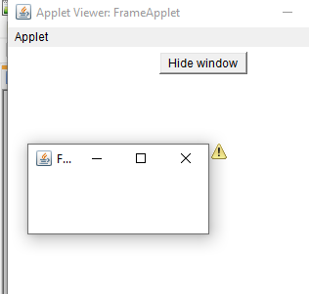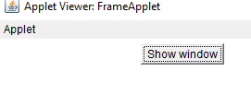

**Scrollbar Demo**

import java.awt.*;

import java.applet.*;

/*<applet code="Scrollbardemo.class" height=500 width=500></applet>*/

public class Scrollbardemo extends Applet

{

Scrollbar sc = new Scrollbar();

public void init()

{

add(sc);

}

}

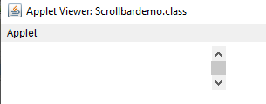

**Canvas demo**

import java.awt.*;

import java.applet.*;

import java.awt.event.*;

/*<applet code="Canvasdemo" width=500 height=500></applet>*/

public class Canvasdemo extends Applet

{

Canvas c;

public void init()

{

c = new Canvas();

c.setBackground(Color.blue);

c.setSize(50,60);

add(c);

}

}

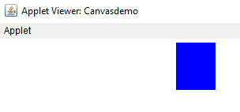

**By button1 and by Button2**

import java.applet.Applet;

import java.awt.*;

/*<applet code="showstatus" width="500" height="500">

</applet>*/

public class showstatus extends Applet

{

TextField tf1=new TextField(15);

Button b1=new Button("FIRST");

Button b2=new Button("SECOND");

public void init()

{

add(tf1);

add(b1);

add(b2);

}

public boolean action(Event evt,Object obj)

{

if(evt.target.equals(b1))

{

getAppletContext().showStatus("BY BUTTON1");

tf1.setText("BY BUTTON1");

}

if(evt.target.equals(b2))

{

getAppletContext().showStatus("BY BUTTON2");

tf1.setText("BY BUTTON2");

}

return true;

}

}

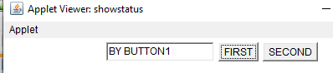

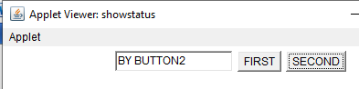

**Label**

import java.awt.*;

import java.applet.*;

/*<applet code="LabelDemo.class" height=500 width=500></applet>*/

public class LabelDemo extends Applet

{

Label l1 = new Label("one",Label.LEFT);

Label l2 = new Label("two",Label.CENTER);

Label l3 = new Label("three",Label.RIGHT);

public void init()

{

add(l1);

add(l2);

add(l3);

}

}

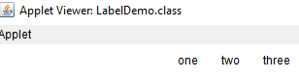

**TextField Demo**

import java.awt.*;

import java.applet.*;

/*<applet code="TextFielddemo.class" height=500 width=500></applet>*/

public class TextFielddemo extends Applet

{

TextField t1 = new TextField("TF 1");

TextField t2 = new TextField("TF 2");

public void init()

{

add(t1);

add(t2);

}

}

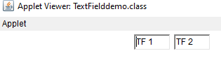

**TextArea Demo**

import java.awt.*;

import java.applet.*;

/*<applet code="TextAreademo.class" height=500 width=500></applet>*/

public class TextAreademo extends Applet

{

TextArea t1 = new TextArea("Hello",1,3);

TextArea t2 = new TextArea("t2",4,30);

public void init()

{

add(t1);

add(t2);

}

}

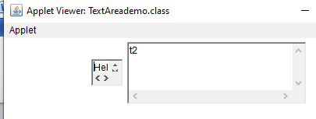

**checkbox**

import java.awt.*;

import java.applet.Applet;

/*<applet code="checkbox.class" height=200 width=200></applet>*/

public class checkbox extends Applet

{

Checkbox c1 = new Checkbox("pen");

Checkbox c2 = new Checkbox("pencil");

Checkbox c3 = new Checkbox("scale");

Button b1 = new Button("Submit");

TextField tf1 = new TextField(20);

public void init()

{

add(c1);

add(c2);

add(c3);

add(b1);

add(tf1);

}

public boolean action(Event e,Object o)

{

String s = new String();

if(e.target.equals(b1))

{

if(c1.getState())

s = s + c1.getLabel();

if(c2.getState())

s = s + " " + c2.getLabel();

if(c3.getState())

s = s + " " + c3.getLabel();

tf1.setText(s);

}

return true;

}

}

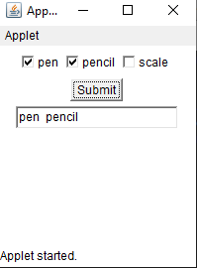

**Checkbox Group**

import java.awt.*;

import java.applet.*;

/*<applet code="checkboxgroupdemo.class" height=200 width=200></applet>*/

public class checkboxgroupdemo extends Applet

{

CheckboxGroup item = new CheckboxGroup();

Checkbox c1 = new Checkbox("add",item,false);

Checkbox c2 = new Checkbox("sub",item,false);

Checkbox c3 = new Checkbox("mul",item,false);

Checkbox c4 = new Checkbox("div",item,false);

Checkbox c5 = new Checkbox("min",item,false);

Checkbox c6 = new Checkbox("max",item,false);

Button b1 = new Button("Submit");

TextField t1 = new TextField(20);

TextField t2 = new TextField(20);

TextField t3 = new TextField(20);

int ans;

public void init()

{

add(t1);

add(t2);

add(c1);

add(c2);

add(c3);

add(c4);

add(c5);

add(c6);

add(b1);

add(t3);

}

public boolean action(Event evt, Object arg)

{

int no1 = Integer.parseInt(t1.getText());

int no2 = Integer.parseInt(t2.getText());

if(evt.target.equals(b1))

{

if(item.getSelectedCheckbox()==c1)

{

ans = no1+no2;

t3.setText("SUM: " +String.valueOf(ans));

}

}

if(evt.target.equals(b1))

{

if(item.getSelectedCheckbox()==c2)

{

ans = no1-no2;

t3.setText("SUB: " +String.valueOf(ans));

}

}

if(evt.target.equals(b1))

{

if(item.getSelectedCheckbox()==c3)

{

ans = no1*no2;

t3.setText("Mul: " +String.valueOf(ans));

}

}

if(evt.target.equals(b1))

{

if(item.getSelectedCheckbox()==c4)

{

ans = no1/no2;

t3.setText("Div: " +String.valueOf(ans));

}

}

if(evt.target.equals(b1))

{

if(item.getSelectedCheckbox()==c5)

{

ans = (no1<no2)?no1:no2;

t3.setText("Min: " +String.valueOf(ans));

}

}

if(evt.target.equals(b1))

{

if(item.getSelectedCheckbox()==c6)

{

ans = (no1>no2)?no1:no2;

t3.setText("Max: " +String.valueOf(ans));

}

}

else

;

return true;

}

}

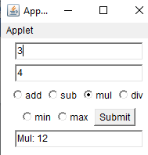

**choice demo**

import java.awt.*;

import java.applet.*;

/*<applet code="Choicedemo.class" height=500 width=500></applet>*/

public class Choicedemo extends Applet

{

Choice c = new Choice();

public void init()

{

c.add("1");

c.add("2");

c.add("3");

c.add("4");

c.add("5");

add(c);

}

}

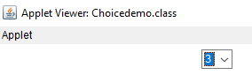

**Listdemo**

import java.awt.*;

import java.applet.*;

/*<applet code="Listdemo.class" height=500 width=500></applet>*/

public class Listdemo extends Applet

{

List l = new List();

public void init()

{

l.add("1");

l.add("2");

l.add("3");

l.add("4");

l.add("5");

add(l);

}

}

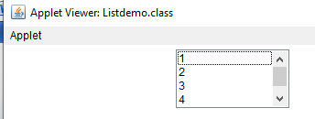

**Menu using init method**

import java.awt.*;

import java.awt.event.*;

import java.applet.*;

/*<applet code="MenuDemo2.class" height=500 width=500></applet>*/

public class MenuDemo2 extends Applet implements ActionListener

{

Frame f;

Label l;

public void init()

{

f = new Frame("Menu Demo");

l = new Label("Select any MenuItem from File Menu");

MenuBar mb = new MenuBar();

Menu mn = new Menu("File");

MenuItem mi1 = new MenuItem("New");

mi1.addActionListener(this);

MenuItem mi2 = new MenuItem("Open");

mi2.addActionListener(this);

MenuItem mi3 = new MenuItem("Save");

mi3.addActionListener(this);

MenuItem mi4 = new MenuItem("Close");

mi4.addActionListener(this);

mn.add(mi1);

mn.add(mi2);

mn.add(mi3);

mn.add(mi4);

mb.add(mn);

f.setMenuBar(mb);

f.setLayout(new FlowLayout());

f.add(l);

f.setSize(300,300);

f.setVisible(true);

}

public void actionPerformed(ActionEvent o)

{

if(o.getSource() instanceof MenuItem)

{

l.setText(o.getActionCommand());

}

}

}

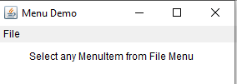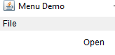

**menudemo using public static void main**

import java.awt.*;

import java.awt.event.*;

import java.applet.*;

public class MenuDemo extends Applet implements ActionListener

{

Frame f;

Label l;

public MenuDemo()

{

f = new Frame("Menu Demo");

l = new Label("Select any MenuItem from File Menu");

MenuBar mb = new MenuBar();

Menu mn = new Menu("File");

MenuItem mi1 = new MenuItem("New");

mi1.addActionListener(this);

MenuItem mi2 = new MenuItem("Open");

mi2.addActionListener(this);

MenuItem mi3 = new MenuItem("Save");

mi3.addActionListener(this);

MenuItem mi4 = new MenuItem("Close");

mi4.setActionCommand("I am close command");

mi4.addActionListener(this);

mn.add(mi1);

mn.add(mi2);

mn.add(mi3);

mn.add(mi4);

mb.add(mn);

f.setMenuBar(mb);

f.setLayout(new FlowLayout());

f.add(l);

f.setSize(300,300);

f.setVisible(true);

}

public void actionPerformed(ActionEvent o)

{

if(o.getSource() instanceof MenuItem)

{

l.setText(o.getActionCommand());

}

}

public static void main(String args[])

{

MenuDemo ob = new MenuDemo();

}

}

**Flow Layout**

import java.awt.*;

import java.applet.*;

/*<applet code="FlowLayoutex.class" height=500 width=500></applet>*/

public class FlowLayoutex extends Applet

{

public void init()

{

Button b1 = new Button("1");

Button b2 = new Button("2");

Button b3 = new Button("3");

Button b4 = new Button("4");

Button b5 = new Button("5");

add(b1);

add(b2);

add(b3);

add(b4);

add(b5);

setLayout(new FlowLayout(FlowLayout.CENTER));

}

}

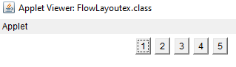

**BorderLayout**

import java.awt.*;

import java.applet.*;

/*<applet code="Borderlayoutex.class" width="800" height="500"></applet> */

public class Borderlayoutex extends Applet

{

public void init()

{

setLayout(new BorderLayout());

add(new Button("wel"), BorderLayout.NORTH);

add(new Button("come"), BorderLayout.SOUTH);

add(new Button("rose"), BorderLayout.EAST);

add(new Button("tiny"), BorderLayout.WEST);

add(new Button("apple"), BorderLayout.CENTER);

}

}

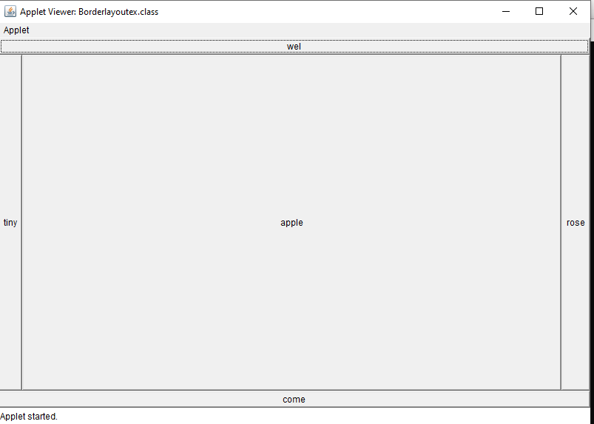

**GridLayout**

import java.awt.*;

import java.applet.*;

/*<applet code="GridLayoutex.class" height=500 width=500></applet>*/

public class GridLayoutex extends Applet

{

public void init()

{

setLayout(new GridLayout(3,3,10,20));//r,c,c,r

Button b1 = new Button("1");

Button b2 = new Button("2");

Button b3 = new Button("3");

Button b4 = new Button("4");

Button b5 = new Button("5");

Button b6 = new Button("6");

Button b7 = new Button("7");

Button b8 = new Button("8");

Button b9 = new Button("9");

add(b1);

add(b2);

add(b3);

add(b4);

add(b5);

add(b6);

add(b7);

add(b8);

add(b9);

}

}

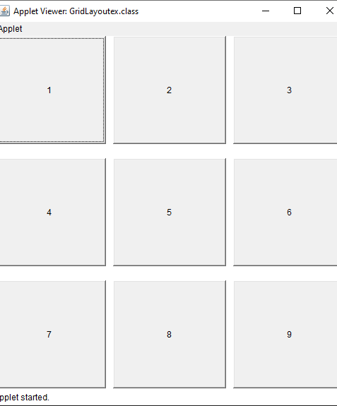

**Cardlayout**

import java.awt.*;

import java.applet.Applet;

/*<applet code="Cardlayout2.class" width=500 height=500></applet>*/

public class Cardlayout2 extends Applet

{

Panel panelCards = new Panel();

Panel p1 = new Panel();

Panel p2 = new Panel();

Panel p3 = new Panel();

Canvas c1 = new Canvas();

Canvas c2 = new Canvas();

Canvas c3 = new Canvas();

CardLayout cards = new CardLayout();

public void init()

{

c1.setBackground(Color.blue);

c2.setBackground(Color.yellow);

c3.setBackground(Color.pink);

p1.setLayout(new BorderLayout());

p2.setLayout(new BorderLayout());

p3.setLayout(new BorderLayout());

p1.add(c1);

p2.add(c2);

p3.add(c3);

panelCards.setLayout(cards);

panelCards.add(p1);

panelCards.add(p2);

panelCards.add(p3);

setLayout(new BorderLayout());

add(panelCards);

}

public boolean mouseDown(Event e,int x,int y)

{

cards.next(panelCards);

return true;

}

}

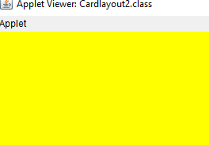After every touch panel change its colour.

**ActionListener**

import java.applet.Applet;

import java.awt.*;

import java.awt.event.*;

/*<applet code="Actionlistenerd" width="180" height="70">

</applet>*/

public class Actionlistenerd extends Applet implements ActionListener

{

TextField tf1=new TextField(10);

TextField tf2=new TextField(10);

Button b1=new Button("ADD");

Button b2=new Button("SUB");

Button b3=new Button("Mul");

Button b4=new Button("Div");

Button b5=new Button("Min");

Button b6=new Button("Max");

Label l1=new Label("ANSWER");

TextField tf3=new TextField(10);

public void init()

{

setLayout(new GridLayout(5,2));//r,c

add(tf1);

add(tf2);

add(b1);

add(b2);

add(b3);

add(b4);

add(b5);

add(b6);

add(l1);

add(tf3);

b1.addActionListener(this);

b2.addActionListener(this);

b3.addActionListener(this);

b4.addActionListener(this);

b5.addActionListener(this);

b6.addActionListener(this);

}

public void actionPerformed(ActionEvent ae)

{

int n1=Integer.parseInt(tf1.getText());

int n2=Integer.parseInt(tf2.getText());

if(ae.getSource()==b1)

tf3.setText("SUM:"+String.valueOf(n1+n2));

if(ae.getSource()==b2)

tf3.setText("SUB:"+String.valueOf(n1-n2));

if(ae.getSource()==b3)

tf3.setText("Mul:"+String.valueOf(n1*n2));

if(ae.getSource()==b4)

tf3.setText("Div:"+String.valueOf(n1/n2));

if(ae.getSource()==b5)

{

if(n1<n2)

{

tf3.setText("Min: "+String.valueOf(n1));

}

else

{

tf3.setText("Min: "+String.valueOf(n2));

}

}

if(ae.getSource()==b6)

{

if(n1<n2)

{

tf3.setText("Max: "+String.valueOf(n2));

}

else

{

tf3.setText("Max: "+String.valueOf(n1));

}

}

}

}

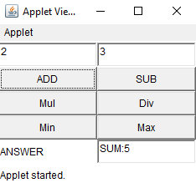

**ActionEvent demo**

import java.awt.*;

import java.applet.*;

import java.awt.event.*;

/*<applet code="ActionEventdemo.class" height=500 width=500></applet>*/

public class ActionEventdemo extends Applet implements ActionListener

{

Button b1 = new Button("Hello");

TextField t1 = new TextField(10);

public void init()

{

add(t1);

add(b1);

b1.addActionListener(this);

}

public void actionPerformed(ActionEvent o)

{

t1.setText("Hello");

}

}

